# **RACI template**

## Context

RACI stands for Responsible, Accountable, Consulted, Informed. It is a responsibility matrix that outlines the roles of individuals against various tasks or deliverables.

|  |  |
| --- | --- |
|  |  |
| Responsible | Those responsible to do the work to achieve the outcome required |
| Accountable | Those who authorise the work and who are ultimately accountable for the correct completion of the work |
| Consulted | Those who are consulted about the work at various stages of its progress |
| Informed | Those who are kept informed about the work |

## Instructions

Input the standard information about the contract, supplier etc at the top of the ‘RACI’

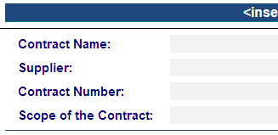

Data to be completed

* Review the matrix and change any RACI area or activity that doesn't apply with an area that does apply to the Agency

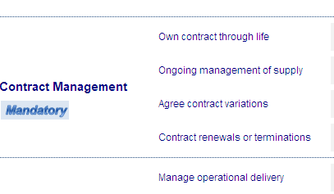

The RACI **area** can be changed as the organisation sees fit

Each activity area can also be changed to match the activities that the organisation wants to include in the matrix

* Assign names or roles to the specific RACI boxes which relate to the work being performed

The RACI contains an area to include the person 'Responsible', 'Accountable', 'Consulted' and 'Informed' for each activity. Fill in the name of the role which corresponds to whether the role is 'Responsible', 'Accountable', 'Consulted' or 'Informed' for the specific RACI activity

RACI activity



* Commmunicate the RACI to all relevant people so they all understand their involvement within the contract

Note: A RACI should be completed for every contract

## RACI Template

RACI stands for Responsible, Accountable, Consulted, Informed. It is a responsibility matrix that outlines the roles of individuals against various tasks or deliverables.

|  |  |
| --- | --- |
|  |  |
| Contract name |  |
| Supplier |  |
| Contract number |  |
| Scope of the contract |  |
| Person responsible for reviewing the RACI |  |

|  |  |  |  |  |  |  |  |  |
| --- | --- | --- | --- | --- | --- | --- | --- | --- |
| RACI area | Activity area | Responsible |  | Accountable |  | Consulted |  | Informed |
| Contract administration  **Mandatory** | Update contract database |  |  |  |  |  |  |  |
| Communicate contract change |  |  |  |  |  |  |  |
| Manage contract reporting |  |  |  |  |  |  |  |
| Contract management  **Mandatory** | Own contract through life |  |  |  |  |  |  |  |
| Ongoing management of supply |  |  |  |  |  |  |  |
| Approve contract variations |  |  |  |  |  |  |  |
| Contract renewals or terminations |  |  |  |  |  |  |  |
| Performance delivery  **Mandatory** | Manage operational delivery |  |  |  |  |  |  |  |
| Collate SLA/KPI outcomes |  |  |  |  |  |  |  |
| Lead supplier performance reviews |  |  |  |  |  |  |  |
| Service quality  **If relevant** | Check service quality |  |  |  |  |  |  |  |
| Maintain specifications |  |  |  |  |  |  |  |
| Approve alternate work methods |  |  |  |  |  |  |  |
| Governance framework  **If relevant** | Chair steering committee |  |  |  |  |  |  |  |
| Define limits to procurement roles |  |  |  |  |  |  |  |
| Contract management plan template (CMPT)  **If relevant** | Write CMPT |  |  |  |  |  |  |  |
| Review and approve CMPT |  |  |  |  |  |  |  |
| Communicate CMPT |  |  |  |  |  |  |  |
| Methodology, tools and templates  **Optional** | Develop procurement methodology |  |  |  |  |  |  |  |
| Produce standard tools and templates |  |  |  |  |  |  |  |
| Approve use of templates |  |  |  |  |  |  |  |
| Train and communicate |  |  |  |  |  |  |  |

## Using this tool

This tool accompanies the [Contract management - Goods and services procurement guide](https://www.buyingfor.vic.gov.au/contract-management-goods-and-services-procurement-guide)

© State of Victoria 2012 (Victorian Government Purchasing Board)

[](http://creativecommons.org/licenses/by/3.0/au/)

This work is licensed under a [Creative Commons Attribution 4.0 Australia licence](http://creativecommons.org/licenses/by/3.0/au/). You are free to re-use the work under that licence, on the condition that you credit the State of Victoria as author. The licence does not apply to any images, photographs or branding, including the Victorian Coat of Arms, the Victorian Government logo and the Department of Treasury and Finance logo.

Copyright queries may be directed to [IPpolicy@dtf.vic.gov.au](mailto:IPpolicy@dtf.vic.gov.au)